**DAILY ONLINE ACTIVITIES SUMMARY**

|  |  |  |  |  |  |  |  |  |
| --- | --- | --- | --- | --- | --- | --- | --- | --- |
| **Date:** | **27-05-2020** | | | | | **Name:** | **Nihal Rafiq** | |
| **Sem & Sec** | **4th A** | | | | | **USN:** | **4AL18CS052** | |
| **Online Test Summary** | | | | | | | | |
| **Subject** | | **Object Oriented Concept** | | | | | | |
| **Max. Marks** | | **30** | | **Score** | | | **29** | |
| **Certification Course Summary** | | | | | | | | |
| **Course** | **Introducer Coding for Beginners: an HTML and CSS Online Course** | | | | | | | |
| **Certificate Provider** | | | **BitDegree** | | **Duration** | | | **60 hours** |
| **Coding Challenges** | | | | | | | | |
| **Problem Statement:**  **1. Write a C program to sort an array of integers in ascending order and display the sorted array and number of passes performed for sorting** | | | | | | | | |
| **Status: Executed** | | | | | | | | |
| **Uploaded the report in Github** | | | | | **Yes** | | | |
| **If yes Repository name** | | | | | **https://github.com/nihal-art/lockdown-coding** | | | |
| **Uploaded the report in slack** | | | | | **Yes** | | | |

Online Test Details:

The online test was from module 4 of OBJECT ORIENTED CONCEPT (18CS43). Duration of test is 30 minutes from 9.15am to 9.45am .30 questions of multiple choice.

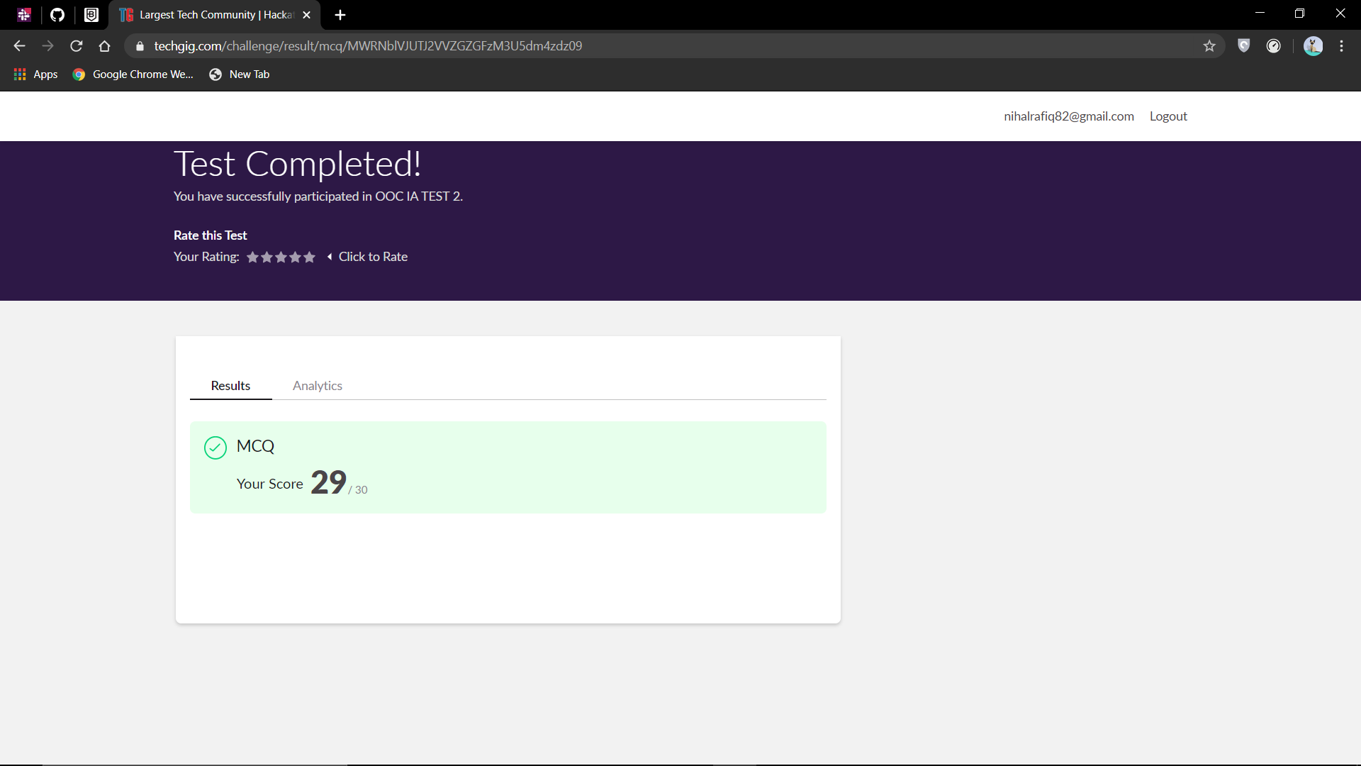

Certification Course Details:

I have opted my Online Certification Course in BitDegree. The course I have opted is Introducing Coding for Beginners: an HTML and CSS Online Course.

The course covers the following topics:

* Basic web development
* Creating forms, buttons and other elements
* HTML coding basics
* CSS basics

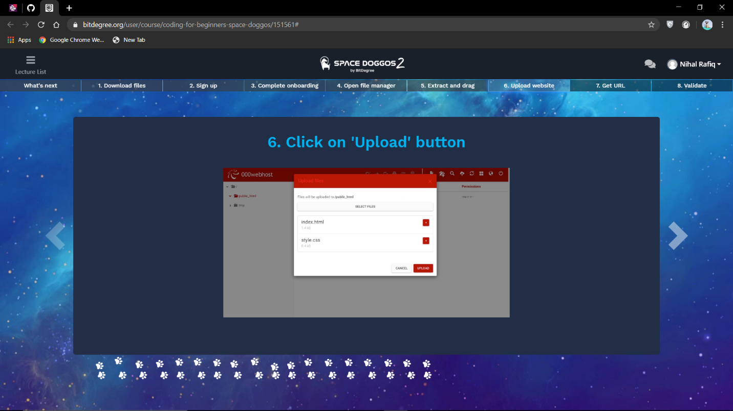

Coding Challenges Details:

**CODING CHALLENGES:**

1. Write a C program to sort an array of integers in ascending order and display the sorted array and number of passes performed for sorting.

In Bubble sort, each pass consists of comparison each element in the file with its successor (i.e. x [i] with x [i+1]) and interchanging two elements if they are not in the proper order. The array may be sorted in any pass. If the array is sorted, then remaining passes should be skipped off.

